P.1 LITERACY ONE A LESSON NOTES TERM III
Lesson 1
THEME: OUR ENVIRONMENT
Spelling

environment
surroundings
plants
birds
animals

What is Environment?
Environment means people and their surrounding.
Things in our environment[ components ]

people
air
lakes
rivers
mountains
plants
land
hills
insects
birds
swamps
animals
valleys

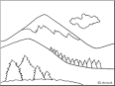 | 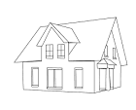 | 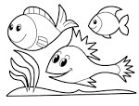 | 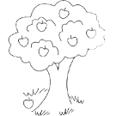

Activity
Nature walk around the school to see things in the environment.
Exercise
Draw and name any two things you have seen
Lesson 2

spelling

environment
valleys
mountains
rivers
swamps

uses of things in the environment
plants
Some plants are a source of food.
They give us medicine
They give us shade
They give us timber

Animals

Some animals give us food.
Some animals are used for transport.
Some animals keep security.
Activity
Observing pictures of uses of plants from the text book.
Exercise
Which animal keeps security?
How are the following animals useful to people?
donkey________________________________________

oxen__________________________________________
LESSON 3 and 4
Spelling

medicine
shade
security
transport

Uses of lakes and rivers
They are sources of water
They are sources of fish.
They are homes for some wild animals.
They help in transport.
Uses of mountains and hills
They are homes for some wild animals e.g gorillas.
They help in the formation of rainfall.
They have good soils for growing crops.
They are tourist attractions.
Land
For building .
For growing crops.
For making bricks.
It is a home for some wild animals.
Activity
Children will go out and observe the hills in the environment.
Exercise.
Draw and name a river and a lake.

Lesson 5
Spelling

building
bricks
tourist
attraction

Living things in our environment.
What are living things?
Living things are things which;

grow
move
feed
respire
excrete
reproduce

Some of the living things in our environment are;

plants
animals
people
birds
insects

There are two main groups of living things. These are;
plants
animals
Activity
Children will go out to see the living things in the environment.
Exercise
Draw and name any two living things you have seen.

Lesson 6
Spelling

move
excrete
respire
reproduce
feed

Examples of living things
- Plants eg.
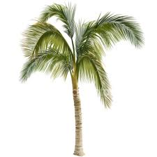 | 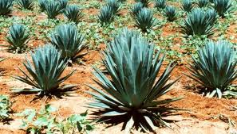  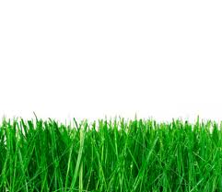 | 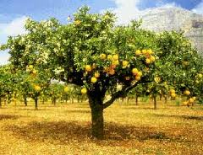
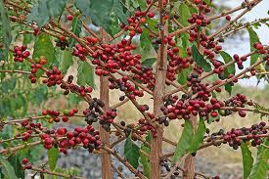  palm trees | sisal | 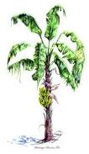  orange plant
coffee plant | grass | banana plants
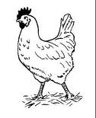
B. Animals eg
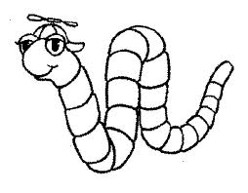  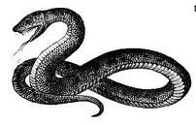 | 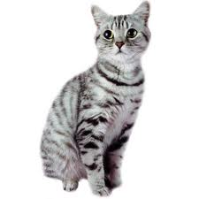 |  |  | 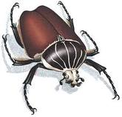 | 
worm | snake | cat | hen | insect | man

C. Birds like hens, eagles, ducks, etc
D. Insects like grasshoppers, ants, flies, etc
Activity
Nature walk around the school to see things found in the environment.
Exercise
Draw and name any one plant you have seen in the environment.
Ref: Understanding Integrated Sci. bk. 1 page 16-17.
Fountain Pr. Sci. book 1 page 18-22.

Lesson 7
Spelling

coffee
Insect
worms
snake

Parts of a plant: (This should be done practically to help children identify parts of a plant.)
1.There are three main parts of plant.

leaves
stem
roots

2.Other parts of a plant are;
flowers, fruits, bud and branches
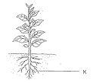

Activity
Observing a plant and naming the different parts of a plant.
Exercise
Draw a plant and name the following parts;

1.leaf
2.stem
3.roots

Lesson 8
Spelling

roots
Stem
Leaf
fruit

The parts we eat on different plants
- Leaves like cabbage, dodo, nakati, ebbuga
- Roots like cassava, carrots
- Stems like sugarcanes, yams
- Fruits like mangoes, oranges, apples, etc
plantPPPP  NAME OF A PLANT N | Picture  PICTURE | PART EATEN
sugarcane  sugarcane | 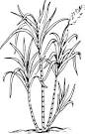 | stem
yam  yam | 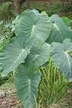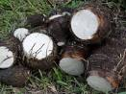 | stem
Sweet potatoes  sweetpotato | 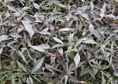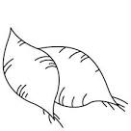 | roots
Mango  mango | 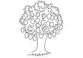 | fruit
cabbage | 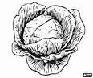 | leaves

Lesson 9
Spelling
leaves
onion
cassava
cabbage

Non living things in our environment
Non living things are the things which do not feed, excrete, reproduce, respire, grow and move.
Examples of non living things are;
hills, mountains, land, cups, plates, tables, etc
Activity
Children will observe non living things in the environment.
Exercise
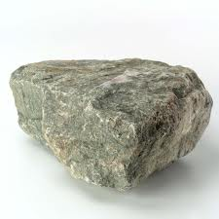
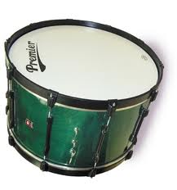
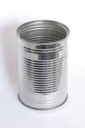
Draw and name any three non living things

Stone tin drum

Integrated Sci bk 1 page 21.
Lesson 10
Sources of water
We can get water from the following sources;

lakes
rivers
oceans
springs
rain
boreholes
seas
swamps
streams
wells

The major source of water is rain.

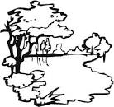 | 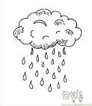 | 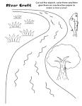 | 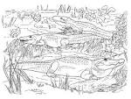

Activity

Observing and reading sources of water from the text book

Exercise
Draw and name any three sources of water.
Lesson 11
spelling

spring
ocean
seas
stream
river

Uses of water

For bathing
For cooking
For drinking
For bathing
For washing
For watering plants
For mopping
For swimming

.

Children will demonstrate some uses of water e.g drinking,washing,watering,etc.
Exercise
1.How is water used in the kitchen?
2.Draw and name any four uses of water.
Ref: Comprehensive S.St bk 1 pg 35-36.
Mk Integrated Sci bk 1 page 79-80.
Lesson 12
Spelling

drinking
mopping
building
washing

Activities that spoil our environment

- cutting down trees.
- bush burning.
- poor fishing methods e.g catching fish with poison.
- hunting wild animals in reserved areas (game parks)
- building / farming in swamps or wetlands.
- poor farming methods e.g over cultivation.
- brick making.
- poor waste disposal
- over grazing
- leaving un covered holes
- pollution

Activity
Children will move out to see areas where the environment is destroyed
Exercise
Mention any three activities that spoil our environment.

Lesson 13

Burning
Over grazing
Hunting
Pollution
farming

2. Ways of caring for environment [conservation of the environment]

- Planting more trees
- Not burning bushes
- Not building in swamps
- Not digging in swamps
- Not hunting wild animals in reserved areas
- Not burning polythene bags
- Planting trees with other crops together
- Use good methods of fishing
- Mulching
- Watering plants
- Water harvest
- Proper waste disposal
- Agro forestry

Project
Children to do any activity that conserves the environment like planting a tree. ( give other alternatives)
Exercise
Give any three ways of caring for the environment.
Ref: Mk Integrated Science bk. 2 pg 37

